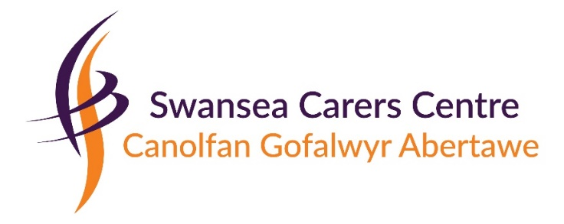

Dear Applicant,

Title of Post: Time 4 You Co-ordinator

Please find enclosed our application pack which contains:
Job Advert
Job Description and Person Specification
Application Form
Equal Opportunities Monitoring Form

Please complete the application form paying particular attention to the person specification and explaining how your knowledge, skills and experience demonstrate that you meet those required for the post. We would also be grateful if you could complete and return the Equal opportunities monitoring form but this is not essential.

Further information is available on our website www.swanseacarerscentre.org.uk

If you would like an informal discussion about the role feel free to call me on 01792 653344. The closing date for applications is Thursday 30th September 2021.

We are happy to accept a hard copy or emailed application but it is your responsibility to ensure that we have received it. Contact details can be found at the bottom of the page.
Only shortlisted candidates will be contacted and asked to attend for interview.
Thank you for your expression of interest in this post.

Yours sincerely

Emma Daniels
Deputy Director

