Carers I.D./
Emergency Card

Application Form

Name of Card Holder (to appear on card) |  | Name of person you care for
Address for card to be mailed to: |  | Health Condition | Date of Birth  dd/mm/yyyy
Postcode: |  | Relationship to you:  ie. Child/Spouse/Friend
Contact No: |  | I look after someone who cannot manage without my help due to illness, disability, a mental health condition or an addiction.
Email:

Date of Birth: dd/mm/yyyy
Only fill in the form below if you wish your card to also hold Emergency contact details. Otherwise the back of your Carers ID Card will be blank.

Emergency Card Details

Name of Emergency Contact: (this will not appear on the card)

*Emergency telephone number:

*This needs to be the number of someone who can be contacted if an emergency arises and you are unable to get to the person you care for.

Carers ID Card Criteria

To be eligible for a card you must:

- Live in Swansea
- Be caring for someone who cannot manage without your help
- Be registered with Swansea Carers Centre (if your name is not on our database someone will be in touch with you)

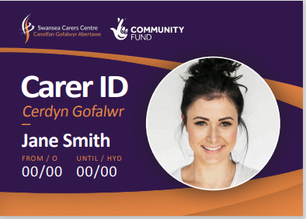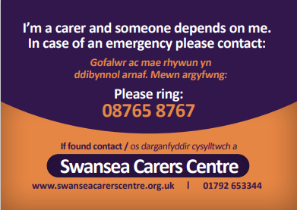

Photograph ID instructions
Photos are an essential part of your application for a Carers ID Card. We only accept passport quality photographs.
Email: You can attach a digital photograph by scanning your passport photograph or a selfie taken on a smartphone that follow passport photo requirements. The photograph you attach to your email must be in JPG file format. Send to karen@swanseacarerscentre.org.uk
Post: You can print out this form and mail it along with your passport photograph to: Karen Keey, Swansea Carers Centre, 104 Mansel Street, Swansea. SA1 5UE.

